**Artifactory: Its nothing but collection of files(Repository)**

**Whenever we create a build before deploying it will store in Repository, we have 2 types of Artifatory Repository’s**

We have 2 Artifactory Repository’s

* Nexus Repository
* Jfrog Artifactory Repository(Its latest one, most of the companies will use this)

Every Artifact have its own Naming convention that we will provide as per our requirement (Name,date…etc)

**Sonarcube:**

**Its is used by Developers to validate the Static code like checking any Bugs are there or any vournerbilities (is there any chance to hake the code by any one)**

**It is developer tool**

**Sonarcube will support almost all 20 programming languages**

**ZenTimestamp Plugin**

**We have to plugin in Jenkins that we will Install**

**Now we are going to set TimeStamp for Total Jenkins(for all Projects)**

**Configure system>**

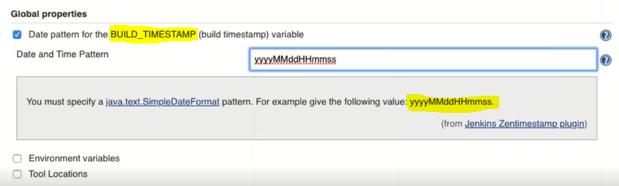

Above we have set **BUILD_TIMESTAMP** for all projects(its Global configuration).

We can set our own syntax for our projects individually based on our requirement.

**Now we are going to configure for Project base**

